

- 2026)
T Arun
2520030456
AIDS
CO – 3 Graph Algorithms & Optimization Techniques

Case Study Topic: Travel Flow Shortest Route Finder using Dijkstra Algorithm
Work Done Summary:
In this case study, we implemented Dijkstra’s Algorithm in the Travel Flow Smart Travel Booking System to find the shortest path between cities. The system uses weighted graphs to represent travel routes and calculates the minimum travel distance efficiently.

Implementation Details:
- Represented cities and travel routes using weighted graphs.
- Stored distances between connected cities as edge weights.
- Implemented Dijkstra’s Algorithm using Priority Queue.
- Calculated shortest distance from source city to destination city.
- Displayed optimized travel route with minimum distance.

Result: Screenshot/Output

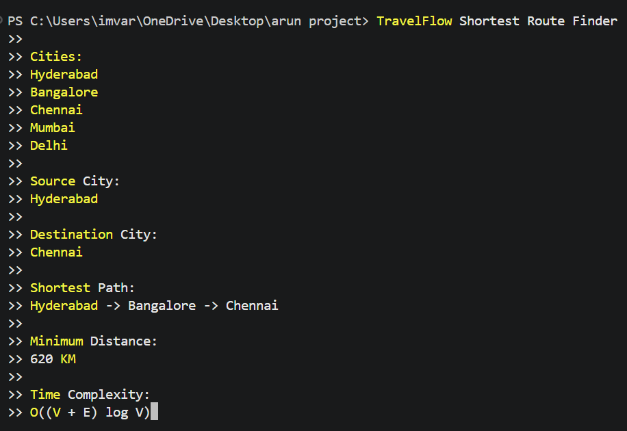

Dijkstra’s Algorithm successfully calculated the shortest travel route between cities.
The system reduced travel distance and improved route optimization efficiency.
Compared to traditional searching methods, graph algorithms provided faster and more accurate route planning for large travel networks.

GitHub Link: https://github.com/Arun888star

